

**Functional Requirement Document**

**-**

**CCBA Investment App**

|  |
| --- |
| Phase 1 – Securities Trading and Market Information |

# Functions Highlight

1. **An investment app that fulfills the need of both Hong Kong & Mainland customers**

* Layout (Incorporate / Merge with mainland style in the whole design, support 2-3 set of themes in different colours)
* Content (Simplified Chinese with mainland style terms to be provided by CCBA)
* Colour setting (up/down colour)

1. **Application Flow**

* Support mobile token logon with biometric or PIN code (after mobile token setup in CCBA Mobile Banking)
* Provide Simple and easy to use, smooth and quick securities trading process, multiple shortcut to trading related function
* Support cash and margin fund transfer
* Support eCorporate Action section for customer to view & reply
* Support eIPO subscription and application status enquiry
* Support set up and view securities eStatement
* Provide extensive market information and support streaming quote function in specific sections: Stocks Watchlist, Stock portfolio, Stock Quote Details
* Support display of promotion banner and Bank’s announcement in the app

1. **Customization**

* Personalized homepage shortcut, top watchlist and portfolio, Market info to be displayed, etc
* Price alert setup
* Setting: Lang (EN, TC, SC), up/down colour, app theme colour, sequence of stock market info displayed
* Gain/Loss of the portfolio and the average price of each stock holding

1. **App feature**

* Push notification for market info, price alert, order confirmation (as an additional means for notification), promotion, eCorproate Action etc
* Horizontal view for displaying charts, portfolio, watchlist, etc
* In order to draw the public awareness, we would like to have the **app-call-app capability** (i.e. linked with the major market information provider). Through the app-call-app function, customer can easily login CCBA trading apps and place order without need to close the information apps and search our trading apps. Currently BOCHK and CitiBank were added their trading functions with the information providers as the additional window for customer to login.

1. **Capacity to accommodate the addition of below features in next phases**

* More investment products such as Mutual Fund, FX Margin trading platform, Bonds, FX trading and FXLD trading platform, Account opening on other investment products (exclude those account which the customer already opened)
* AI Investment Advisory tools
* Chatroom function that allow communication between RM and customers

# Function List

**Phase 1 (Post-Logon functions are highlighted in yellow)**

1. Homepage
   1. Bank’s announcement
   2. Stock Search (support stock name or code search)
   3. Portfolio (showing account outstanding balance with all holdings according to the securities account selected)
   4. 7 shortcuts in icon allowing personalization
      1. Order Status (Today/10 trading days, allow sorting and filtering)
         1. Amend Order
         2. Cancel Order
      2. Transaction History (Today/7 days/1 month, allow sorting and filtering)
      3. Stock Watch (Setup, view and Edit and the list sync with the record in OB/MB)
      4. Fund Transfer (Cash/Margin)
      5. Margin Account details
      6. eStatement (Setup and view)
      7. eIPO (subscription and application status enquiry)
      8. eCA (Dividend Announcement, Rights Issue Announcement, Open Offer Announcement, Voluntary Unconditional Announcement)[View and reply]
   5. Promotion Banner
   6. Key Info sections
      1. Top Watchlist showing first 4 stocks in the list
      2. Personalized Latest News and Research Reports based on holdings or watchlist
      3. Market Info (Indice, top stocks, company news)
2. Securities Trading (HK Shares & SSE + Shenzhen Stocks)
   * 1. Order Placement (support stock quote)
     2. Order Amendment
     3. Order Cancellation
3. Market Info (Based on current information provider)
   1. Indices (Hong Kong, China and Asia Pacific)
   2. Index Constituents (HK)
   3. Hong Kong Top 20 (Stocks, Warrants, CBBCs, by Turnover/Volume/%Gainers/%Losers)
   4. Market News (Top News, Analysts’ Views, Market Intelligence, Research Report, etc)
   5. IPOs (Current/Upcoming/Listed, support calendar view)
   6. Industry Constituents
   7. Industry Top 10 (By market cap)
   8. ETFs
   9. Dividend History (1 month history, allow searching)
   10. Corporate Events
   11. 52-Week High/Low
   12. Stock Connect Quota Balance (Daily)
4. Settings and others
   1. Enable/Disable Mobile Token access
   2. eAlert : stock price, eCorporate Action, eStatement
   3. Push notification
   4. App theme
   5. Language
   6. Sequence of Stocks market info displayed
   7. Homepage Horizontal view
   8. Bank’s announcement(e.g. service suspension, enhancement, security tips, etc)

# IT Requirement

1. **On-going enhancement support**

- Please state the development team location.

- 深圳研发团队：深圳市福田区彩田路7018号新浩E都A座40楼

- 北京研发团队：北京市朝阳区阜通东大街1号院望京SOHO塔3B单元3203-3206室

1. **On-going production support**

- Please state the support model in case of production problem, including escalation contact and corresponding Service level agreement (SLA).

- Please specify the production support team location. On-site support is preferred.

-

1. **Technology**

- Provide overall system diagrams (including connection outside CCBA data center)

- List all technologies used including programming language

- List all software and hardware requirement (including external network connection)

- Need to follow CCBA standard for single sign-on. CCBA will provide API for use.

1. **Scalability**

- Scalability of solution is expected. Please specify the solution in case maximum capacity is reached.

1. **Flexibility**

- Flexibility of adding new functions by CCBA or other vendors is expected. Please confirm this is feasible.

1. **Availability (if the solution involving vendor’s data center)**

- Please specify the details of the resilience arrangement (including DR site).

- Please specify the RTO (Recovery time objective) and RPO (Recovery point objective).

1. **Documentation**

* The following documents are expected. Please specify the document list which will be provided.
  + Functional specification
  + Technical specification
  + SIT test plan and case
  + UI design guideline
  + User manual

1. **Quality Assurance**

* Please specify the quality assurance of the solution.

1. **Project team structure and size**

* Please provide the team structure and team size for this project.

1. **Source code custody**

* Please specify which component of the source code can be owned by CCBA.

|  |
| --- |
| **Next Phases** |

# Function List

1. **Mutual Fund**

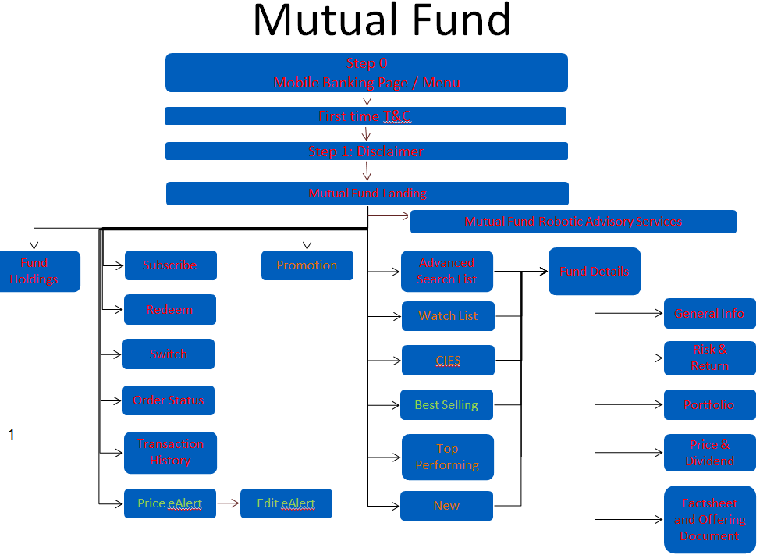

**Mutual Fund High level requirement**

* Fund information was retrieved from Morningstar
* Functions (Fund Info and Trading) available is the same as that of OB
* The data (Fund watch list, alert setting, transaction info, etc) for OB and MB should be the same
* The layout/navigation should align with existing CCB (Asia) Mobile App
* Add Mutual Fund Robotic Advisory Services
* Vendor provides datafeed in xml/JSON/other format

1. **Mutual Fund Robotic Advisory Services 智能投顧**

* Vendor builds the function to provides clients with suggested fund portfolios
* Vendor provides the section methodologies
* Retrieve client information from CCBA systems (e.g. IPQ) and obtain information from questions via online
* Fund portfolio selection can be based on client’s life cycle, fund sector, client’s risk profiling/investment objectives etc.
* Regular rebalancing on the Fund portfolios

1. **Mutual Fund Fund Information**
   1. Fund Search (input search/Advanced Search)
   * Fund Search result
   * Fund Details
     + General Information
     + Risk & Return
     + Portfolio
     + Price & Dividend
     + Factsheet & Offering Documents
   1. Designated Fund list
   * CIES Funds
   * Best Selling Funds
   * Top Performing Funds
   * New Funds
   1. Personalized setting
   * Fund Watch List (view/edit)
   * eAlert (view/edit)
2. **Mutual Fund Trading**

* Subscribe
* Redeem
* Switch
* Order Status
* Transaction History
* Fund Holdings

1. **FX Margin and FX Linked Deposit**
   1. **Order Placement**
   2. **Order Status**
   3. **Portfolio**